Revealed: Preston Bus Station youth centre revised designs

17 M AY, 2016 BY [LAURA MARK](http://www.architectsjournal.co.uk/laura-mark/1201745.bio) aj

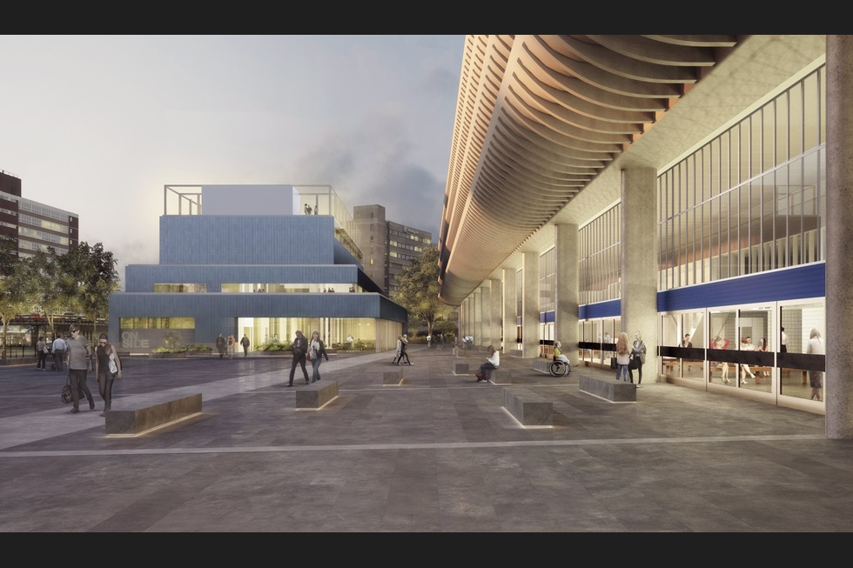

John Puttick Associates has significantly reworked its designs for a new £23 million youth centre at Preston’s Grade II-listed bus station

The emerging US firm said it had revised its [contest-winning concept](http://www.architectsjournal.co.uk/news/emerging-new-york-practice-wins-preston-bus-station-contest/8687673.article) to make the scheme ‘less complex and more affordable’ and to respond to concerns raised by the Twentieth Century Society and Heritage England.

The New York-based practice saw off competition from Flanagan Lawrence, Letts Wheeler Architects, Preston-based Cassidy + Ashton and Sane Architecture from France to win the high-profile job in August 2015.

The firm’s original concept connected the proposed Youth Zone to the neo-Corbusian concrete landmark designed by BDP. However the new blueprints create a ‘clear distinction’ between the two buildings.

John Puttick Associates’ new scheme also allows the 2,600m2 youth club, which includes sports, arts and performance spaces, to be run independently.

The pavilion-like design features a glazed facade and colonnade which is designed to be ‘dynamic and inviting’.

Practice founder John Puttick said: ‘One of our key objectives has been to design a building maximising available public space in and around the bus station to create a major new square for Preston. This supports the civic quality of the project.

‘It has also been important to respond to the proudly utilitarian quality of Preston Bus Station by designing a new neighbour that shares and celebrates this robustness, just as youth centre used for sport and as a place for creativity should do.’

Clare Price, senior conservation adviser for the Twentieth Century Society, also commented: ’The Twentieth Century Society has been involved in detailed consultations with the design team to ensure a secure future for the listed Preston Bus Station.

’The society commends the careful consideration of the impact of the new Youth Zone on the listed building’

’The society commends the team’s attention to detail in the bus station refurbishment and careful consideration of the impact of the new Youth Zone on the setting of the listed building.’

Jennifer Mein, leader of Preston county council, added: ‘Taking time to get the design right now will help this process in the future. It’s important that we develop plans to gain the necessary planning approval and ensure that we deliver this youth zone for our young people and improve the bus station for everyone to use.’

The practice is also working on the refurbishment of the 1969 bus station where it will pare down the interior, return features to their original colour and reintroduce the building’s Helvetica typeface for signage.

More than 125 practices from 16 different countries registered to take part in the original RIBA-run competition for the job.

Among those known to have entered are Hawkins\Brown, Caruso St John, SimpsonHaugh, RCKa, Moxon Architects and Turner Prize-winner Assemble.

John Puttick Associates’ winning scheme was also the one chosen by the public and by AJ readers in separate online votes.

More than 4,200 people voted for the design they wanted to win the contest at a two-day exhibition held at the bus station and online through the council’s website. These votes were taken into account by the judges when making their final decision.

The revised designs went on display in an exhibition inside Preston Bus Station today (17 May)

**Type of project**youth centre  
**Location** Preston, Lancashire  
**Client** Lancashire County Council  
**Youth** **centre** **operator** OnSide  
**Landscape** **design** Lancashire County Council Highways Department  
**Structural** **engineer** EngineersHRW  
**Environmental** **engineer** Skelly & Couch  
**Acoustic** **engineer** Charcoalblue  
**Planning** **consultant** Cassidy & Ashton  
**Fire** **engineering** **and** **inclusive** **design** Buro Happold  
**Area** 2,600m2

